How to Edit an Existing General Correspondence Process
Once you have created a correspondence process, you can use it again for other correspondence your business unit sends out. It can be used for the same correspondence that goes out on a regular basis (like a newsletter) or it can be used for other correspondence you send (like holiday cards). You’ll just need to update the comments appropriately. Let’s walk through an example:
We have created the UDO FYXX Newsletter General Correspondence Process for the monthly newsletter we send out. It is now time to send it out again. We are going to log into Davie and:
- Click on Marketing and Communications on the Navigation bar
- Click on Manage correspondence under the Donor relations section (if necessary. If you have not been to other classes on Marketing and Communications, Davie may take you straight to the Manage Correspondence screen)
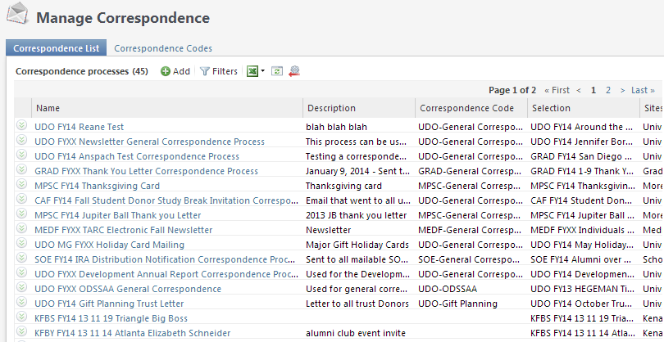

- Search for our process (UDO FYXX Newsletter General Correspondence Process)…using the Filter options if we have trouble easily finding it in the list
- Click on the process name when we find it UDO FYXX Newsletter General Correspondence Process
- Click the link under the Tasks section on the Explorer bar

- We see information related to the last time the process was run
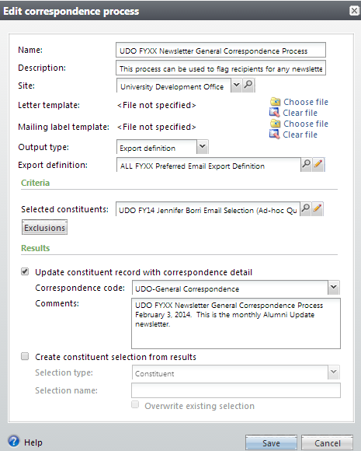

- If you need to change the query that will pull in the constituents you are sending to, do that by clicking on the magnifying glass icon (to choose a completely different query/selection) or the pencil icon (to edit the existing query/selection) if you have sufficient rights to do so (i.e. you have attended a Query class).

- Click on the Exclusions button to ensure you have the proper exclusions listed. In our example, we work for the University Development Office and we are sending out an e-newsletter, so we need to select these exclusions:
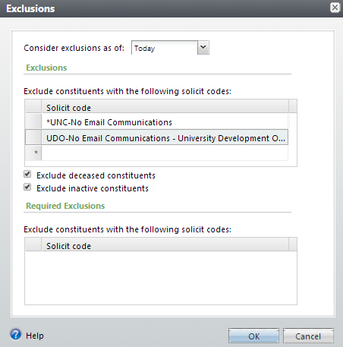

- Edit the Comments field as necessary (in this instance, we are sending the same newsletter, we just need to update the date it is being sent out)

- Click the Save button.
- Contact the Helpdesk and ask that your process be run.

