How to Create a General Correspondence Process
When you create a correspondence process, you specify the selection of constituents to receive the correspondence based on a query or list of imported IDs and the letter to use with the correspondence. You can also specify constituents in the selection to exclude from the correspondence (constituents with particular solicit codes).
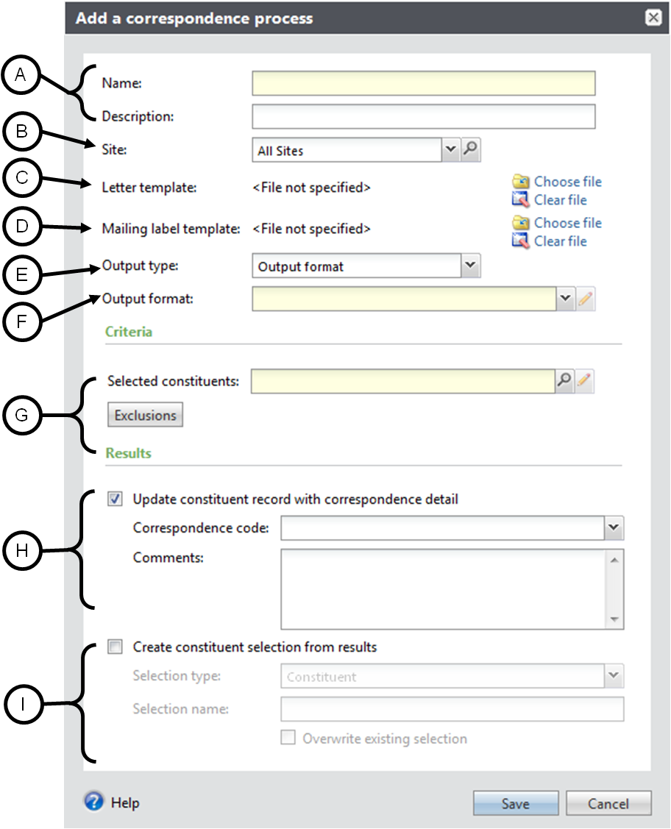
- Enter a name and description for the correspondence, following standard naming conventions.
- Choose your site.
- Click the Choose file icon to search for your Microsoft® Word document if you wish to attach a copy of your letter template to this process. This step is optional.
- If you have created a Microsoft® Word template for labels, click the Choose file icon to search for the label file. This step is also optional.
- Select whether to generate correspondence using fields from an Output format or from an Export definition. We recommend choosing an Export definition. Davie defines the fields to export for each Output format, but the Davie team at Central Development can define the fields to export for an Export definition if the existing ones do not meet your needs.
- Indicate the correspondence output type. If you wish to use an Output format instead of an Export definition we recommend you select Formatted mail correspondence output. This will incorporate seasonal addresses where appropriate and the constituent’s mail preferences. You can click the pencil icon to define additional processing options. **Note – this only appears if Output format is chosen. You will not see this field if you chose Export definition.
- Search for and select a selection group of constituents to mail to. Within the search screen, you can also click Add to create a new ad hoc query. We recommend Dynamic selections, but it is possible to use a Static selection when necessary. Click Exclusions to exclude constituents who request not to be contacted or solicited in specific ways.
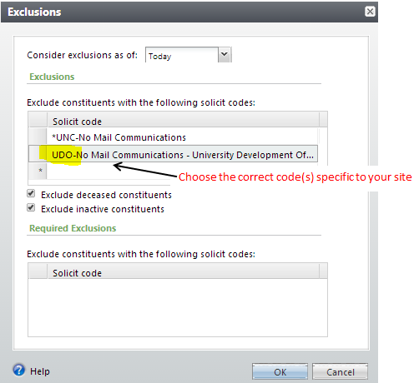
** Note – You must take the Davie 302 – Creating Ad Hoc Constituent Queries class to create these kinds of queries in Davie. If you have not attended Davie 302 – Creating Ad Hoc Constituent Queries, contact the Davie Helpdesk to set this up for you.
- Select this checkbox to update the constituent record with correspondence details. Select the correspondence code. ** Note – if you check this box but do not enter any Comments in the Comment field, the only thing that will appear on the Constituents’ records is the code and the date the process was run. Our recommendation is to enter the name of the process followed by the date the correspondence is being sent and a note referencing what the correspondence is in the Comments field. For example: UDO FYXX All Purpose General Correspondence Process November 19, 2015 Holiday e-newsletter
- Do not select this checkbox to create a selection of the constituents contained in the correspondence process. Creating a selection would be pointless since you already had to create a selection for the process in step G. A selection created at this point would be the same set of constituents minus the ones excluded due to solicit codes. If you wish to pull a final list of everyone who received the correspondence, it is possible to query on the correspondence code.

To run a Correspondence Process once it has been created:
To generate the output for a correspondence, you must first contact the Davie Helpdesk and ask that the correspondence process be run. Please indicate the name of the process and what time frame you prefer it is run in (the date the process is run is the date that will appear on the Constituents’ records).
** Items to Note:
- Once a process has been run, the only way to remove it from Constituents’ records is by manually removing each from each person.
- You can set up a generic general correspondence process that your site/department can use over and over to indicate you have sent out monthly newsletters, etc.
- If you set up a generic general correspondence process to be used multiple times, once it has been run you cannot delete the process. Deleting the process will remove every instance recorded on all Constituent records for every time it was run, not just the most recent run.

